DIS-Shells—Conus- Seminoleconus lybrandi

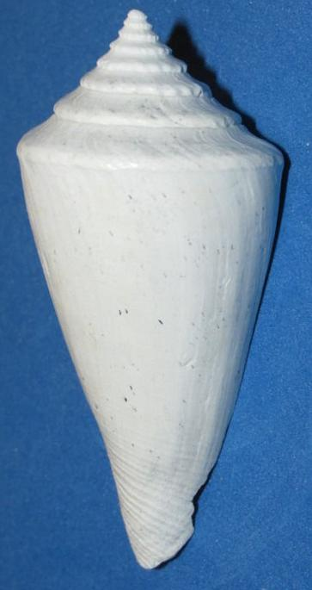 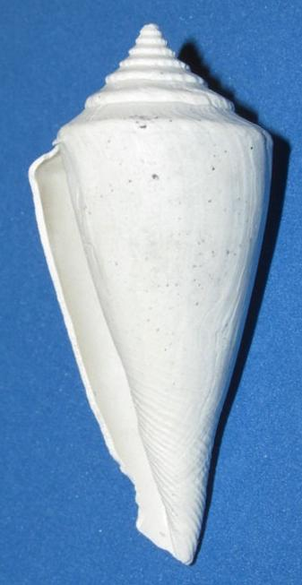

Seminoleconus lybrandi Petuch and Drolshagen, new species, Fruitville member (Petuch unit 4) Tamiani Formation. “Black layer” estuarine facies) in the APAC pit, Sarasota, Sarasota County, Florida. 56 mm.

Reference: Petuch, Eugene J and Mardie Drolshagen. 2001. *Compendium of Florida Seashells*, vol. 1, MdM Publishers, Screen 715. CD.